# Sewage Sludge Supply Curve Construction and Documentation

Prepared by Alex Badgett, Emily Newes, and Anelia Milbrandt

National Renewable Energy Laboratory

# 1. Introduction

The U.S. Department of Energy’s Bioenergy Technology Office (BETO) has begun exploring the bioenergy feedstock potential of the following residential, commercial, and industrial wastes:

* Food waste
* Fats, Oils, and Greases (FOG)
* Sewage sludge
* Animal manure

These materials are produced from various industries and are conventionally difficult to manage and safely dispose of. A low willingness to dispose of these wastes means that they would be readily available for use as bioenergy feedstocks. This document specifically characterizes construction of economic models for sewage sludge and generates preliminary national and state supply curves.

While the focus of this document is on sewage sludge, we also reference biosolids, another term used in the field. Sewage sludge is solids separated during the municipal wastewater treatment process, while biosolids are treated sludge that meets EPA pollutant and pathogen limits for disposal. [1]

We build upon analysis in Milbrandt et al. 2017, which provides an assessment of the total and available wet Waste-to-Energy (WTE) resource potential in the United States and illustrates their geographic distribution.[2]

This work builds upon the aforementioned analysis by characterizing the economic drivers of sludge management, and develops supply curves for the material. Understanding the economics of materials that are not conventionally treated as commodities by their handlers required a different, more flexible approach. The supply curves included in this document depict material economics at a nationwide level, however future work will generate supply curves for individual states and regions.

As noted, sewage sludge is not conventionally assigned a dollar value like a commodity. Often, it is an expense for plants to dispose of the material safely and in accordance with the U.S. Environmental Protection Agency (EPA) standards. This suggests that Publicly Owned Treatment Works (POTW) could be willing to pay some dollar amount for the material to be taken and managed for them. This work seeks to quantify that value, and refers to it as “avoided cost”. This is the cost that sludge producers would be willing to pay a bioenergy plant to accept the material, as long as it is below the value per weight they currently pay to dispose of it.

The following text summarizes methodologies and datasets employed during construction of sludge economic models. Our models consider components of the wastewater treatment process and the costs of each, along with the most common alternatives used to dispose of sludge.

# 2. Process Flow

Sewage sludge treatment is common throughout all areas of the country, however the techniques used to stabilize sludge vary by location, wastewater composition, and POTW needs. We developed a process flow that generally depicted how wastewater is treated at plants across the country and modeled its component costs. We then adjusted the model under a WTE scenario, where sludge was diverted to a bioenergy pathway rather than disposed of in the conventional manner. Figure 1 depicts the conceptual sludge treatment flow with the WTE scenario in place. Costs were assigned one of two classifications: avoided costs, which the POTW would no longer have to pay under a WTE scenario, and added costs, new costs associated with developing sludge as a feedstock under the WTE scenario. Also of note are several sunk costs, which we did not consider in this work since they would not change under the WTE scenario depicted, such as primary and secondary treatment costs.

Sunk Costs

Primary & Secondary Treatment

Land Application

Hauling

Dewatering

Storage

Avoided Costs

Landfill

Added Costs

Incineration

Class A Biosolids

Long Term Storage

Figure 1: Conceptual process flow for sludge treatment at a POTW. Costs avoided and costs added through the given WTE scenario as marked.

For this work, our model assumed that all primary and secondary plant treatment processes were held constant (i.e. sunk costs), and sludge was diverted after treatment to a WTE process on-site. This avoided the costs associated with hauling and dumping sludge at a disposal site. The cost of hauling the sludge and disposing of it are regarded as avoided costs if the sludge is being diverted for use as a WTE feedstock. The model assumed that any bioenergy infrastructure will be developed on site within the footprint of the wastewater treatment plant, negating any costs associated with hauling the sludge to a WTE facility off site.

The plant may require development of some additional processes to ensure sludge meets standards for use as a bioenergy feedstock. We built the model to consider dewatering the sludge and storing it for a short period of time on site. Calls with industry experts suggested that use of dewatering and storage technologies may or may not be in place already, depending on location. To capture the effects of dewatering and storing sludge, scenarios considering them as either added costs or zero costs were added, as we discuss further in Section 6.

# 3. Data Sources

We compiled and analyzed several datasets in this work to differentiate sludge treatment costs among localities (Table 1). In order to construct national-level supply curves, we used state-level economic parameters to estimate state-level costs when data were only available at a national level.

Table 1: Datasets used in this work

|  |  |
| --- | --- |
| Point Resolution | State Resolution |
| POTW Point Locations, Sludge Production and Plant Inflow [2] | Labor Costs (U.S. Bureau of Labor Statistics [3] |
| Landfill Locations and Tipping Fees [4] | Prices of Electricity & Fuel (U.S. Energy Information Administration [5], [6] |
|  | Sludge Disposal Practices (North East Biosolids and Residuals Association [7] |

Unfortunately, detailed plant-by-plant data for how sludge is disposed of is not readily available. Sludge disposal trends were available by state in NEBRA, 2007; therefore generalized trends for the state were depicted in economic modeling for POTW costs.[7] Developing a decision matrix within the model to assign end disposal costs for sludge between different plants is a significant aspect of the economics of the WTE scenario we considered in this work, and is discussed in Section 4.1 below.

The following disposal alternatives were considered in this work:

* Landfilling
* Land application
* Incineration
* Long-term storage
* Class A biosolids treatment

Costs for each of these alternatives were computed in terms of dollars per wet ton of sewage sludge from EPA’s *Handbook for Estimating Sludge Management Costs.*[8]This report provides cost estimation algorithms for the most common sludge treatment and management techniques. Datasets for the amount of solids produced and wastewater inflow were available for POTWs across the country (Milbrandt et al, 2017), which allowed for modeling of costs at a plant-by-plant basis. Estimating the costs at each plant required wage, electricity, fuel and other economic data that was available only by state. This mismatched spatial resolution between inputs created a systematic error in the way the model computed costs, and generalized results to state levels.

# 4. Modeling Sludge Cost & Disposal

**Figure 2: Model decision flow for identifying most common disposal methods for large and small POTWs.**

Biosolids End Use by % of Tons

Small Plant Disposal

Size Distinction

Biosolids Survey

End Use Distinction

Large Plant Disposal

Sludge Production in Wet Tons

Milbrandt et al, 2017

Biosolids End Use by# of POTWs

EPA cost algorithms [8] were digitized in a Python program where we calculated costs for different POTWs using regional economic parameters shown in Table 1. Coupled with the NEBRA sludge end disposal data, our model chooses which disposal alternative is most likely for the plant, then calculates a dollar per ton cost associated with that disposal.

## 4.1 Sludge End-Disposal

The North East Biosolids and Residuals Association (NEBRA) conducted a survey of POTWs across the country to identify end-disposal alternatives for treated sewage sludge (biosolids); the survey results were aggregated at the state level.[7] We used these data in our sludge end disposal modeling and therefore were limited to sludge disposal generalizations state-by-state. Figure 2 depicts the model decision process for determining sludge end-disposal across all POTWs.

For each disposal alternative, the report gives a percent of biosolids produced through that process and a percent of plants utilizing that process. We then used that data in a decision matrix (Table 2) within the model to develop end disposal costs for sludge between different plants under the WTE scenario.

From these state data (NEBRA, 2007), the two most utilized disposal methods by percent of biosolids were identified in our model, along with the percentage of plants in the state utilizing each.

Table 2 shows the decision matrix we used to assign sludge disposal alternatives for a POTW. By considering the percent of biosolids treated and percent of plants utilizing the method for the five disposal possibilities considered, a relative ratio of biosolids per plant is calculated for the two methods that treat the most biosolids for the state. These values are then multiplied by the wet tons of biosolids produced across the state and the number of POTWs in the state, respectively. By dividing the tons of biosolids produced from each method by the number of POTWs using said method, we can estimate the relationship between disposal alternative and POTW size. For each POTW, the plant inflow (from Milbrandt et al, 2017), is related to the state average plant inflow. If POTW flow is greater than state average flow, the plant is assigned the large POTW disposal option, whereas plants treating less than average are assigned the small disposal alternative.

Table 2: Sludge end-disposal decision matrix.

|  |  |  |  |  |  |  |
| --- | --- | --- | --- | --- | --- | --- |
| **Data from NEBRA, 2007 and Milbrandt et al 2017** | **Units** | **Land Application** | **Incineration** | **MSW Landfill** | **Class A** | **Long Term Storage** |
| **Wet tons of biosolids disposed of per end use $$Equation:(State Biosolids Production* \% Biosolids from end use)$$** | [Wet tons] | 500 | 10 | 200 | 50 | 2 |
| **Number of POTWs incorporating end use $$Equation: (State POTWs*\% of POTWs using end use)$$** | [# of POTWs] | 150 | 10 | 20 | 30 | 3 |
| **Wet Tons of Biosolids Per POTW** | [Wet tons/POTW] | 3.3 | 1 | 10 | 1.67 | 0.67 |
| **POTW Size Distinction** | [N/A] | Small POTWs | N/A | Large POTWs | N/A | N/A |

We realize that this method fails to capture several critical aspects of sludge disposal including geographic dependence (e.g. plants closer to metropolitan areas are less likely to land apply sludge because of land availability restrictions) and localized regulations (some cities directly regulate how sludge is to be disposed of within their jurisdiction). Given the lack of coverage and uniformity of biosolids disposal data across all 50 U.S. states, we feel that this method captures the disposal variability to the closest extent possible.

## 4.2 Cost Components

Our model determines the cost of components of the sewage sludge treatment process that would be avoided if the sludge were used as a WTE feedstock, per the scenario outlined in Figure 1. These avoided costs are equal to the cost of the sludge disposal alternative identified for the plant per Section 4.1. In addition to the disposal components, the added costs for sludge dewatering and short-term storage were modeled and used in cost scenarios.

Figure 2 shows the framework for determining disposal costs. Datasets associated with a particular process are cited outside of the yellow brackets. We utilized similar process flows for computing costs of land application, incineration, and all other cost components in Figure 1, and document them the sections following.

Labor Costs

BLS, 2016

Fuel and Electricity Costs

Maintenance Costs

Inflation Indices

End-Disposal Method

(Fig. 2)

Construction and Capital Costs

Mibrandt et al, 2017

Sludge Production in Wet Tons

O&M Costs

NEBRA, 2007

State Biosolids End-Use

Cost Per Wet Ton

EPA, 1985

EIA, 2017a,b

EPA, 1985

Figure 2: Model process flow for determining a cost per ton for disposing of sludge, along with the associated data sources.

## 4.3 Individual Disposal Practices

The following figures document cost aspects of five different sludge end disposal alternatives we considered in this work. These aspects were quantified through cost algorithms developed from the EPA report: *Handbook for Estimating Sludge Management Costs*.[8] Figures and text represent the most important aspects of cost per ton determination for each disposal alternative, but do not document every aspect of each alternative. Please reference the EPA manual for a quantified and detailed discussion on these component cost curves.

### 4.3.1 Agricultural Land Application

Figure 4 shows cost evaluation framework for agricultural land application of sewage sludge. The model determines the number and size of trucks needed to haul and spread sludge, then scales operating and maintenance costs appropriately. Not accounted for within this process is the availability of agricultural lands near the POTW, and the increased hauling distance needed to access sufficient acreage for larger amounts of sludge.

Capital Costs

Labor, Fuel and Electricity Costs

BLS, EIA

Number and Size of Haul Vehicles

Acreage Needed for Land Application

EPA,

1985

Sludge Land Application

O&M Costs

Milbrandt et al, 2017

Sludge Production in Wet Tons

Figure 3: Model cost evaluation framework for agricultural land application of sewage sludge.

### 4.3.2 Incineration

Model evaluation of incineration of sludge is directly scaled to the amount of sludge being produced at the POTW. Supplemental fuel and labor costs are directly dependent on the amount of sludge being incinerated. Incinerating sludge is often done in areas without sufficient space to land apply or landfill it, however the general public does not always welcome incineration of sludge. Costs associated with low public acceptance of this disposal technique are not considered. The EPA cost model for incineration was adjusted to account for large plants incinerating sludge, as the existing EPA function began to increase incineration costs in response to higher amounts of incinerated sludge. Once a $/wet ton threshold is reached in our incineration model, it holds the cost per wet ton constant at $50. Real world costs are likely to continue decreasing past this $50 mark, however sufficient real-world incineration cost data was not available to revise this cost function to that extent.

Capital Costs

Labor, Fuel and Electricity Costs

BLS, EIA

Incineration Infrastructure

Supplemental Fuel Needed for Firing

EPA, 1985

Sludge Incineration

O&M Costs

Milbrandt

et al, 2017

Sludge Production in Wet Tons

Figure 4: Cost evaluation framework for sewage sludge incineration.

### 4.3.3 Long Term Storage

Sewage sludge long-term storage is used by a small percentage of POTWs.[7] Cost of this technology is directly dependent on both the tons of sludge produced and the amount of time the sludge is to be stored. The time of storage was not reported within the NEBRA report used in this analysis; therefore, was assumed to be 180 days. Cost evaluation framework to determining sludge long-term storage is shown in Figure 6.

Capital Costs

Labor, Fuel and Electricity Costs

BLS, EIA

Storage Residence Time

EPA, 1985

Sludge Long Term Storage

O&M Costs

Milbrandt

et al, 2017

Sludge Production in Wet Tons

Storage Volume Required

Figure 5: Cost evaluation framework for determining sludge long-term storage costs.

### 4.3.4 Landfill Disposal

Landfilling of sludge is a relatively common disposal alternative, and is used in areas without sufficient open space for land application. Our model assumes that the plant purchases trucks used to haul sludge to the landfill, the number and size of which is proportional to the amount of sludge the plant produces. A landfill tipping fee specific to the area in dollars per ton is then added to the cost of purchasing and operating the haul trucks. [4]

Capital Costs

Labor, Fuel and Electricity Costs

BLS, EIA

Number and Size of Haul Vehicles

Landfill Tipping Fee

EPA,

1985

Sludge Landfill Disposal

O&M Costs

Milbrandt et al, 2017

Sludge Production in Wet Tons

Figure 6: Cost evaluation framework for determining sludge landfill disposal costs.

### 4.3.5 Class A Biosolids

Figure 8 illustrates the developed model framework for computing Class A biosolids generation costs. Class A biosolids are those of the highest quality (as defined by the EPA), and can be disposed of at minimal cost to the POTW, commonly as compost or soil fertilizers. However, the plant still has to process its sludge to a degree sufficient to be classified as Class A. There are numerous different ways to achieve this. In this work, we assumed the POTW stores, dewaters, and composts sludge to reach Class A standards. All of these component costs are computed and summed to give the estimated cost per ton of producing Class A biosolids.

Capital Costs

Labor, Fuel and Electricity Costs

BLS, EIA

Composting System

EPA, 1985

Class A Biosolids Generation

O&M Costs

Milbrandt et al, 2017

Sludge Production in Wet Tons

Dewatering and Sludge Storage

Figure 7: Cost evaluation framework for determining sludge Class A biosolids disposal costs.

### 4.3.6 Cost Curves

Figure 9 illustrates the developed cost functions for this work. These graphs assume constant economic parameters across all points, including labor, landfill tipping fees, fuel cost, etc. to illustrate model cost values as a function of POTW wastewater inflow. All of the curves show economies of scale driving the cost of these sludge disposal alternatives lower with higher amounts of POTW wastewater inflow.

Land application costs are more oscillatory than others as a result of the model changing the number and size of trucks needed as a function of POTW size. This creates behavior similar to a step function, and is the direct cause for the noisy sections of the curve shown. The incineration curve flattens at $50 per wet ton, as discussed in Section 4.3.2.

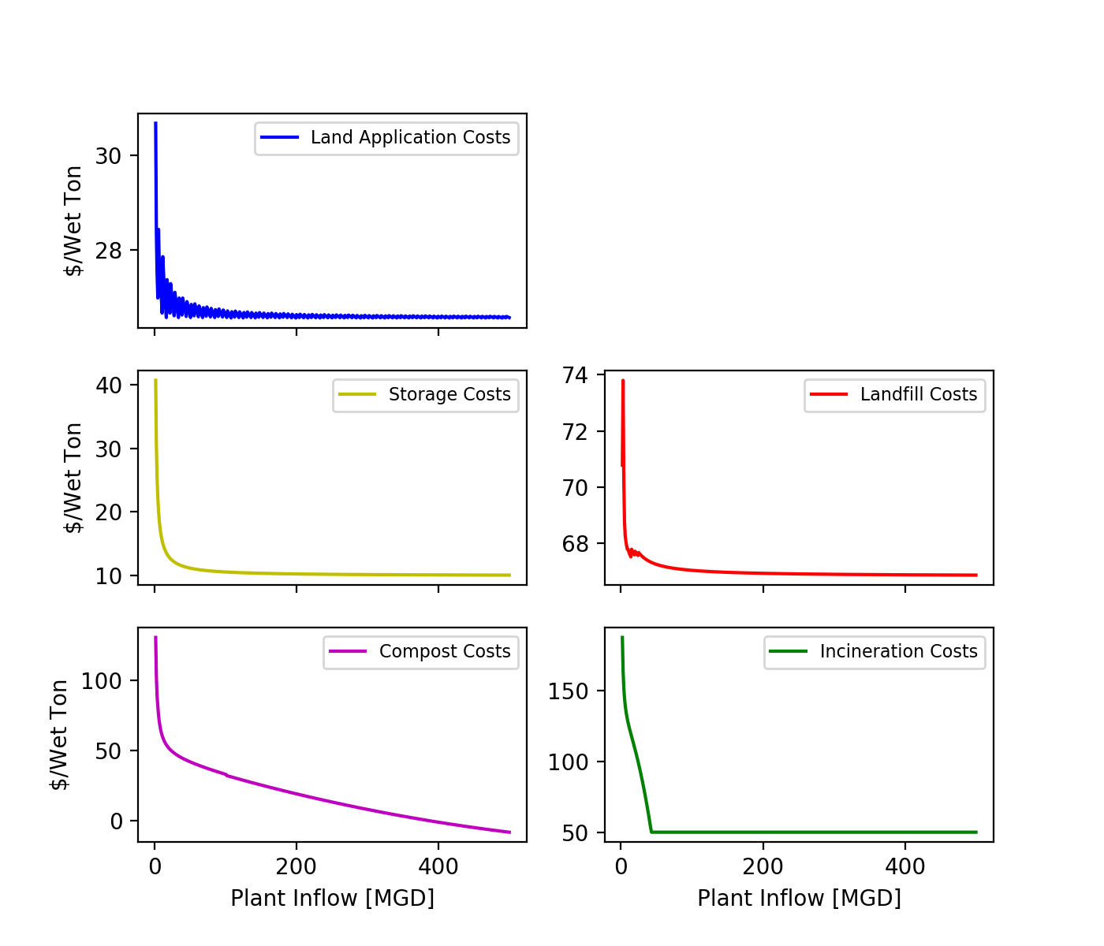

General cost Ranking, low to high:

1. Land Application
2. Storage
3. Landfill
4. Compost
5. Incineration

Figure 8: Cost functions for the five discussed sludge disposal alternatives. Note that the graphed curves are on separate y-axes.

# 5. Limitations

In this work, we developed a model that depicts the wastewater treatment industry at a national level, which merits discussion of several noteworthy limitations, presented and discussed in this section.

## 5.1 Geographic Variability

The needs and standards for wastewater treatment vary spatially across the country, along with treatment plant design. Plants are designed to best accommodate the composition of the incoming waste as well as meet standards for disposal of remaining solids. This model does not currently capture these variations and how they play into the economics of sludge generation. As an example, plants in California almost always dewater sludge because the state’s strict disposal standards minimize the number of available land application sites, requiring sludge be transported long distances to its final disposal site. Contrastingly, states with less produced sludge are able to store sludge in liquid form for long periods of time until it may be land applied. States with large amounts of agricultural land usually land apply sludge on fields, eliminating the need for those POTWs to pay landfill tipping fees. These examples demonstrate the variance in process between treatment plants and the associated variance in sludge management cost. This model accounts for disposal variances to some extent by distinguishing disposal trends by state, however the lack of detailed published literature on these issues makes any more detailed analysis difficult.

Sludge produced from treatment plants varies in composition and form. The EPA develops baseline regulatory criteria for how treated sludge may be disposed, but allows states the ability to develop more stringent or focused disposal standards.[9] In these cases sludge treatment standards may vary from state to state, as operators are best suited to treat sludge to the state or municipalities disposal standards. These standards can change the treatment costs and technologies used at POTWs, a factor which was not accounted for in this work.

## 5.2 Cost Model Timeframe

As noted in Section 4, cost models for different sludge treatment processes were identified in literature and used in the construction of supply curves. The following component costs were modeled in this work:

* Landfill disposal costs
* Land application costs
* Incineration costs
* Long-term storage costs
* Class A biosolids treatment costs
* Short-term storage costs
* Dewatering costs

These processes can be considered either avoided and additional costs under the WTE scenario discussed in Section 2. By developing dollar per ton costs for each of the listed components, they can be added or subtracted as per the model scenario.

The component costs were adapted from those developed by the EPA and published in the 1985 *Handbook for Estimating Sludge Management Costs.*[8]This document provides cost equations for all prevalent sludge treatment and disposal alternatives; however it has not been updated since it’s initial publication. Capital and construction costs were updated using estimates of the Engineering News Record Construction Cost Index (ENRCCI) and Marshall and Swift Equipment Cost Index (MSECI). Therefore, costs were updated to reflect inflation, however the significant age of the models used is still likely to create discrepancies.

Scale and technical capabilities of wastewater treatment technologies have evolved significantly since the EPA handbook was published in 1985, something our developed model does not currently reflect. Although many of the treatment and disposal processes used are the same, the scale and degree of implementation of each has likely changed since the original publication. Secondly, advances in technology have likely fundamentally changed capital and operating costs of wastewater facilities beyond those captured in 1985 in the EPA publication. The EPA cost curves were used in this work as no other more current literature exists for estimating sludge treatment costs at the scale needed. Although several sources of sludge disposal costs exist, cost determination methodologies were not documented in ways sufficient for characterization and use in this work.

## 5.3 Model Scalability

Application of a cost model over a large number of POTWs as was done in this work necessitates consideration of the model’s range of applicability. Costs were developed primarily as a function of the amount of sludge being treated in the plant. The EPA Handbook can develop costs for plants of all sizes, however the accuracy of these cost determinations becomes more uncertain when approaching the upper and lower bounds of POTW size. [8] The EPA handbook was designed to be applied for POTWs treating around 50MGD, and its ability to determine costs for very small and very large POTWs is not well documented.

All of the considered cost algorithms depict economies of scale for POTW operations (Figure 9). The minimum plant size considered in this work is one treating 1 million gallons per day (MGD) of wastewater influent. POTWs treating less than this value were omitted from cost modeling to evaluate costs within a reasonable level of confidence for the model, and under the premise that WTE development will be focused on larger POTWs. National supply curves were segmented by POTW size to illustrate model behavior for the different POTW sizes, and the amount of sludge treated by each subset.

Understanding the applicability of component costs of the model requires a significant amount of real world cost data. Published cost data is available from several different sources, but lacks the uniform methodology to confidently be used in evaluating the applicability of our model. For internal use, POTWs commonly determine the cost per ton for sludge management processes; however each method of cost evaluation varies. Plants can omit capital costs, amortize them for a different lifespan, account for different aspects of sludge treatment under a particular category, etc. Without a standardized cost evaluation structure, simply taking $/ton values and comparing them with ones generated in this work would not yield accurate conclusions.

# 6. Supply Curves

Figure 10 shows a series of compiled national cost curves for sludge produced at POTWs. Our model maps all disposal costs for the considered plants as negative. This indicates that consumers of sewage sludge (WTE plants) could presumably be paid by POTWs to take the sludge. Figure 10 shows a series of two national supply curves for sewage sludge, with the model applied to two different size classifications. Since WTE development is likely to be focused on the largest POTWs, we modeled plants treating greater than 10 but less than 50 MGD and those treating greater than 50 MGD in the Figure below.

Figure 9: Draft national sewage sludge supply curve for plants treating greater than 10 MGD and greater than 50 MGD.

The pie charts in Figure 11 present modeled sludge end disposal for two other POTW size classifications, illustrating the variance in end-disposal among different sized plants. The predominant change between these two figures is sludge that is incinerated vs landfilled. Percentage of landfilling decreases for smaller plants while incineration increases. This is a likely result of the geographic location of POTWs, as larger plants are commonly nearer municipal areas where public approval of sludge incineration is lower.

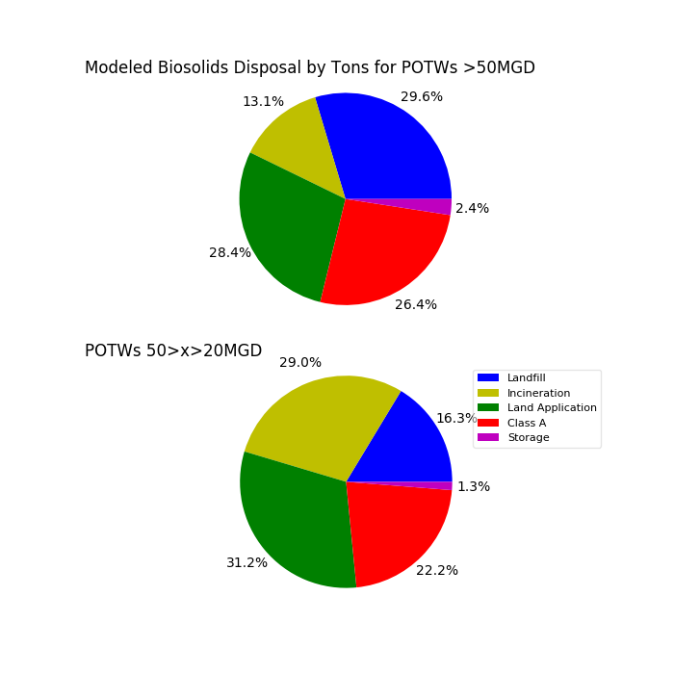

Figure 11: Comparison of modeled sludge end disposal for runs including different sizes of POTWs.

The state supply curves in Figure 12 were aggregated by county; therefore, the number of counties within the state corresponds to the number of data points within the supply curve. States producing more tons of sludge develop longer supply curves, while small states with low sludge production are clustered in the upper-left corner of the Figure.

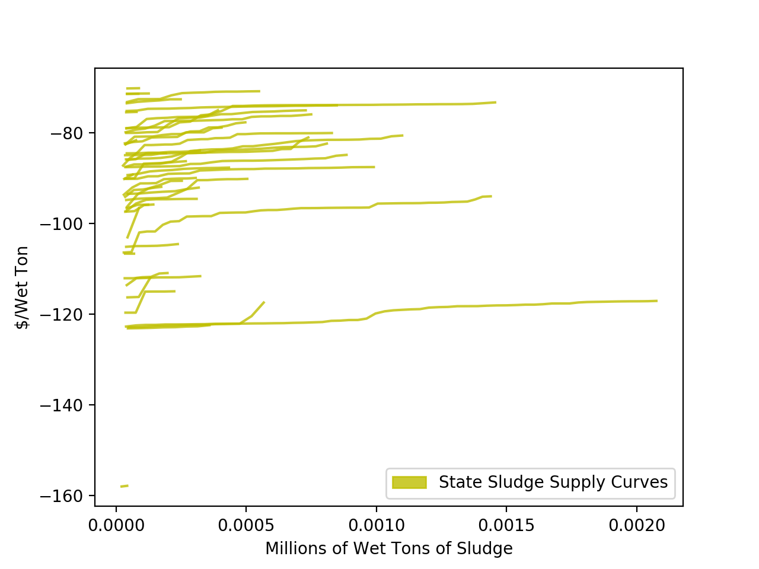

Figure 12: Draft sludge supply curves for U.S. states.

# 7. Process Scenarios

Figure 13 shows an example of the possible scenarios that can be defined within our model. The scenario shown assumes that every plant would require development of sludge dewatering and storage technologies to utilize sludge as a WTE feedstock.

Figure 13 displays the baseline national curve along with a dewatering and storage scenario supply curve. It suggests that sludge is still available at a negative cost in this scenario, albeit a lesser negative cost, since the additional costs of storage and dewatering are less than the avoided costs of sludge disposal.

Figure 13: National sewage sludge supply curves with dewatering and sludge storage as added costs.

# 8. Discussion & Conclusions

As discussed in Section 7, nearly the entirety of sewage sludge across the country is modeled at a negative cost to WTE users. This then poses the question of why WTE utilization of sludge is not being adopted at a higher rate if it is as economically advantageous as our modeling suggests it is. We propose the following attributes are responsible for this trend:

* POTWs already generate energy from sludge to some extent with methane capture from anaerobic digestion
* Strict regulation of POTWs makes operators hesitant to adopt early stage technologies
* Municipally operated plants can lack the capital investment necessary to adopt WTE

Many plants already use anaerobic digestion of sludge as a primary/secondary treatment technology, with a noteworthy subset using the produced methane in energy applications. Using this methane requires a lower financial commitment than developing standalone WTE technologies, and decreases the economic risk for the plant. Secondly, plants are not as liable to risk losing compliance with administered water permits, as anaerobic digestion is a mature and proven technology.

The EPA and local water boards administer POTWs permits to treat wastewater and dispose of the resulting sludge. Disposal permits are strictly regulated to ensure that sludge is properly managed and disposed. Permits set standards for several sludge compositional factors that control how the POTWs treat influent wastewater. Understanding the effects of a WTE technology on the amount, water content, and chemical composition of sludge is needed to ensure the technology will not alter the plant’s compliance with approved permits.

Municipal POTWs have been historically operated with the intent to manage wastewater in a way that minimally impacts the environment. Generally, convention has not accounted for using sludge to produce fuels or energy. Spurring the development of WTE at POTWs requires a financial commitment to constructing the technology, something which many POTWs many not be able to provide. Cost minimization of wastewater treatment is a predominant goal, and the capital investment needed to pilot WTE at POTWs is not likely to be available at every plant.

In this work, we developed an economic model which constructs supply curves of sewage sludge at a national level. By incorporating regional economic parameters, POTW point locations, and sludge supply, we developed supply curves which capture variance in sewage sludge disposal costs among different geographical areas. Our model concludes that in nearly every case, the expense incurred to treat and dispose of sludge is greater than the costs of processing it further for use as a WTE feedstock, meaning it would be available for aggregation at a WTE plant at a negative cost.

Future work will characterize sludge economics at a regional level by developing finalized state supply curves. These state curves will provide perspective on areas where the economics of using sludge as a WTE feedstock are optimal. Coupled with sludge production values, we will identify areas of the country with the most amount of sludge at an optimal cost.

# 9. References

[1] EPA Region 9, “NPDES Wastewater & Stormwater Permits,” *United States Environmental Protection Agency*, 2017. [Online]. Available: https://www3.epa.gov/region9/water/npdes/sludge.html.

[2] A. Milbrandt, T. Seiple, D. Heimiller, R. Skaggs, and A. Coleman, “Wet Waste-to-Energy Resource Assessment (Pending Publication).”

[3] BLS, “Occupation: Water and Wastewater Treatment Plant and System Operators.” United States Bureau of Labor Statistics, 2016.

[4] W. B. Journal, “Directory of Waste Processing & Disposal Sites,” Waste Business Journal, 2016.

[5] EIA, “Gasoline and Diesel Fuel Update.” United States Energy Information Administration.

[6] EIA, “Average Price of Electricity to Ultimate Customers by End-Use Sector.” United States Energy Information Administration.

[7] NEBRA, “A National Biosolids Regulation, Quality, End Use & Disposal Survey,” North East Biosolids and Residuals Association (NEBRA), 2007.

[8] EPA, “Handbook: Estimating Sludge Management Costs,” United States Environmental Protection Agency, 1985.

[9] A. Badgett and A. Milbrandt, “Policy Analysis of Wet Waste-to-Energy Feedstocks (In progress),” National Renewable Energy Laboratory.